EXP 16

AIM: Design TM using simulator to accept the input string a

nb2n

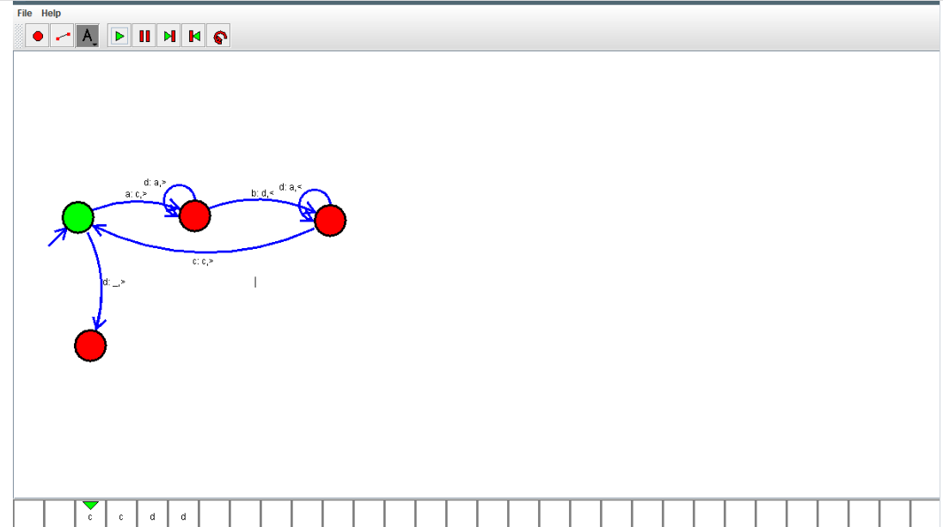

OUTPUT:



RESULT: Design TM using simulator to accept the input string anb2n is verified